 

**Consent for the Processing of Personal Information: Curriculum Vitae:**

**Full Names: __________MAMOLATELO RONNY PITSI___________________________________**

**Identity Number: __________9112315535082_______________________________**

I hereby consent to the consideration and processing of my Curriculum Vitae (CV) for purposes of (specify one):

Only for the current role

* For the current role and any other roles that may be available now or at any time in the future (subject to the retention time frames below).

I further consent to the retention of my CV for the above purposes for the following time period from the date of my application until (specify one):

31 December of the year of application

30 June of the year following the year of application

* 31 December of the year following the year of application

Alternatively:

I request that my CV is deleted in the event that my application is not successful.

**Data Privacy Notice:**

Your personal information is required for the consideration of a placement at or assignment to BMW (South Africa) (Pty) Ltd. (“BMW SA”) and will not be disclosed to any unauthorised parties. Accordingly, by submitting this form, you consent to the processing of your personal information by BMW SA or any entity duly authorised thereto by BMW SA, in accordance with the prevailing data privacy legislation. Such processing shall include, but not be limited to, the collection, handling, management, storage, safe-guarding and sharing of the data with other BMW Group entities as well as authorised service providers and the trans-border flow of such data across South African borders, if necessary. Should you have any queries or concerns, please contact the BMW SA Data Privacy Protection Officer at dppo@bmw.co.za.

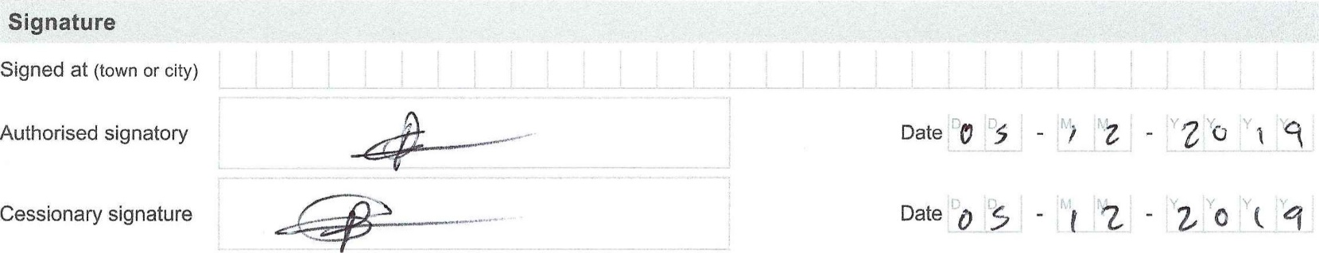

Signature:

Place: PRETORIA WEST

Date: 20/05/2020

Template_Consent_Form_v.1.0